**Traffic Sign Classification Report**

# **Goal /Steps of this project**

* Load the data set
* Explore, summarize and visualize the data set
* Design, train and test a model architecture
* Use the model to make predictions on new images
* Analyze the softmax probabilities of the new images
* Summarize the results with a written report

# **Dataset summary**

Here is the summary of the size and shape of the dataset I am using for training, validation and testing.

* Number of training examples = 34799
* Number of testing examples = 12630
* Image data shape = (32, 32, 3)
* Number of classes = 43

The picture below shows the 43 classes in the german traffic sign data set, along with the same of each unique sign. (For a more clear version, please refer to my notebook source code)

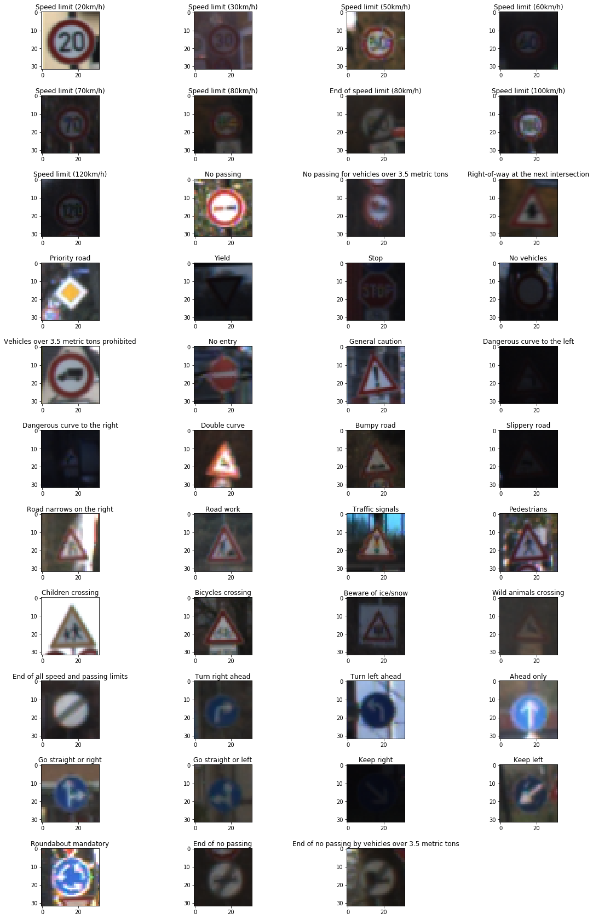

The following histogram picture shows the total number of each traffic sign. As you can see some of the traffic signs have a bigger number of other traffic signs. This might leads to a better prediction for those traffic signs with more samples.

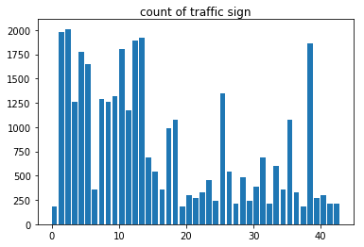

# **Model Architecture**

## Preprocessing

For the preprocessing part, I applied two basic preprocessing of the dataset, Grayscale and

## 3.2 Model architecture

## 3.3 Model training

# **Future Improvement**